

#### A PROJECT REPORT

**ON**

# “VIRTUAL MOUSE USING HAND GESTURE”

#### Project Work is carried out for the partial Fulfillment for the Award

#### of

**“Master of Computer Applications”**

#### From

DEPARTMENT OF COMPUTER SCIENCE AND APPLICATION ATAL BIHARI VAJPAYEE VISHWAVIDYALAYA BILASPUR (C.G)

**BY**

**HITESH DEWANGAN**

**ROLL. NO. – 2210051**

**ENROLLMENT NO. - 2019018967**

SESSION-2023-24

### UNDER THE SUPERVISION OF:

**Dr. H.S. HOTA**

**HOD**

**DEPARTMENT OF COMPUTER SCIENCE AND APPLICATION**

DECLARATION BY CANDIDATE

I, the undersigned solemnly declare that the report of thesis work entitled “**VIRTUAL MOUSE USING HAND GESTURE**” is based on my own work carried out during the course of my study under the supervision of **Dr. H.S. HOTA, HEAD OF A DEPARTMENT,** DEPARTMENT OF COMPUTER SCIENCE AND APPLICATION, ATAL BIHARI VAJPAYEE VISHWAVIDYALAYA, BILASPUR(C.G.).

I assert that the statements made and conclusion drawn is an outcome of my project work. I further declare that to the best of my knowledge and belief the report does not contain any part of any work which has been submitted for the award of any other degree/diploma/certificate in this University or any other University.

(Signature of the Candidate)

HITESH DEWANGAN

## CERTIFICATE BY THE GUIDE

This is to certify that the project report entitled **“VIRTUAL MOUSE USING HAND GESTURE”** submitted in partial fulfillment of the degree of **“MASTER OF COMPUTER APPLICATION”** to the **DEPARTMENT OF COMPUTER SCIENCE AND APPLICATION, ATAL BIHARI VAJPAYEE VISHWAVIDYALAYA, BILASPUR (C.G)** is done by **HITESH DEWANGAN** is an authentic work carried out by him under my guidance

The matter embodied in this project work has not been submitted earlier for award of any degree or diploma to the best of my knowledge and belief.

Signature of the Guide

**Dr. H.S. HOTA**

**HEAD OF DEPARTMENT**

**-**

**DEPARTMENT OF CSA**

## CERTIFICATE BY THE EXAMINER

This is to certified that the project work entitled **“VIRTUAL MOUSE USING HAND GESTURE”** submitted **by HITESH DEWANGAN** has completed under the guidance of **Dr. H.S. HOTA, HEAD OF DEPARTMENT,** DEPARTMENT OF COMPUTER SCIENCE AND APPLICATION, ATAL BIHARI VAJPAYEE VISHWAVIDYALAYA, BLASPUR (C.G) has been examined by the undersigned as a part of the examination for the award of the **MASTER OF COMPUTER APPLICATION.**

#### “Project Examined & Approved”

**Internal Examiner HoD**

**Date: Date:**

## ACKNOWLEDGEMENT

The satisfaction that accompanies the successful completion of any task would be incomplete without the mention of the people who made it possible and whose constant guidance and encouragement crown all the efforts with success. This acknowledgement transcends the reality of formality when we would like to express deep gratitude and respect to all those people behind the screen who guided, inspired and helped us for the completion of our project work.

I am thankful **Dr. H. S. HOTA, HOD, DEPARTMENT OF COMPUTER SCIENCE AND APPLICATION, ATAL BIHARI VAJPAYEE VISHWAVIDYALAYA, BILASPUR(C.G.)** for giving us an opportunity to do the project. I also like to thank all teachers, project guide who has continuously helped and gave valuable suggestions to guide us in the successful completion of the project work.

A special thanks to all my Teachers and friends who have directly or indirectly helped me for completing the task successfully.

**ABSTRACT**

As part of the advancement of human-computer interface, this research offers a virtual mouse system that uses machine learning to analyze hand signals to execute different mouse tasks. This system is built using MediaPipe for hand tracking in real-time activities and OpenCV for processing the video feed stream. Hand landmarks are captured by a webcam where specific gestures for controlling mouse functions such as moving the cursor, clicking with the left mouse button, right mouse button, double-clicking and even drag and drop, brightness and volume control is determined by the system.

The basic operation entails the process of tracing the index finger tip position to enable moving the cursor over the entire screen. Furthermore, relative positions of significant landmarks of the hand are detected and analyzed in terms of angles and distances to distinguish between gestures. For instance, the system can distinguish between left clicks, right clicks and double click by tracking the relative position and direction of the fingers. This novel concept is presented as an interaction without contact and is generally better than the mouse operation.

As for the potential of the proposed system, the advantages include increased accessibility for physically disabled users, as well as a distinct working mechanism for other users. Realized through the use of deep machine learning in combination with real-time hand tracking, this virtual mouse stands as a marked improvement over current solutions to the problem of non-contact input alternatives.

*Keywords: Virtual mouse, Hands gesture control, Artificial intelligence, MediaPipe, OpenCV, Human interaction, Disability.*

INDEX

CHAPTER 1 INTRODUCTION TO THE PROJECT 1 - 2

CHAPTER 2 PROJECT OBJECTIVE 3 - 6

CHAPTER 3 FEATURES 7 - 10

CHAPTER 4 SYSTEM REQUIREMENT 11 - 13

CHAPTER 5 TECHNOLOGIES USED 14 - 17

CHAPTER 6 ARCHITECTURE AND DESIGN 18 - 25

CHAPTER 7 RESULT AND ANALYSIS 26 - 29

CHAPTER 8 OUTPUT 30 - 39

CHAPTER 9 CONCLUSION 40 - 41

LIST OF FIGURES

Fig 6.1. Flow chart of the model

Fig 9.1 Cursor Movement

Fig 9.2 Right Click

Fig 9.3 Left Click

Fig 9.4 Double Click

Fig 9.5 Drag and Drop

Fig 9.6 Volume Up

Fig 9.7 Volume Down

Fig 9.8 Brightness Up

Fig 9.9 Brightness Down

CHAPTER 1

INTRODUCTION TO THE PROJECT

1. **INTRODUCTION**

The "Virtual Mouse Using Hand Gesture" project represents a significant step towards creating a more natural and intuitive human-computer interaction. Traditional input devices such as the mouse and keyboard, while effective, can sometimes limit the ways users interact with their computers, especially in scenarios requiring a hands-free approach or enhanced accessibility.

This project leverages advanced computer vision techniques to detect and interpret hand gestures captured by a webcam, translating these gestures into corresponding mouse and system control actions. By utilizing libraries such as OpenCV for image processing and MediaPipe for real-time hand tracking, the system can recognize a variety of hand gestures with high accuracy and minimal latency.

The implementation includes a comprehensive set of functionalities: moving the mouse cursor, performing left and right clicks, executing double clicks, capturing screenshots, and adjusting the system volume. These actions are all controlled by distinct hand gestures, providing a seamless and efficient user experience.

In essence, the "Virtual Mouse Using Hand Gesture" project aims to provide an innovative alternative to traditional input devices, enhancing accessibility, and opening up new possibilities for human-computer interaction in various applications. Whether for individuals with physical limitations, professionals seeking more dynamic presentation tools, or users looking for a novel way to control their computers, this project offers a versatile and practical solution.

This project is not only a testament to the advancements in technology but also highlights the potential for creating more accessible and user-friendly computing environments. For individuals with physical disabilities, the elderly, or anyone who may find traditional input devices challenging to use, this gesture-based system offers a valuable alternative. Additionally, it provides a novel interaction method for everyday users, enhancing the overall computing experience.

the "Virtual Mouse Using Hand Gesture" project is a pioneering effort to redefine the way we interact with computers. By moving beyond traditional input methods and embracing gesture-based control, it opens up new possibilities for accessibility, efficiency, and innovation in human-computer interaction.

CHAPTER 2

PROJECT OBJECTIVE

1. **OBJECTIVE**

The primary objective of the "Virtual Mouse Using Hand Gesture" project is to create an innovative, hands-free interface that enhances human-computer interaction through the use of intuitive hand gestures. This project aims to achieve the following specific goals:

1. Enhance Accessibility

* **Alternative Input Method**: One of the core goals is to provide an alternative input method for individuals with physical disabilities, making computer usage more inclusive and accessible. By utilizing hand gestures, the system allows users who may have difficulty using traditional input devices to interact with their computers easily and effectively.
* **Ergonomic Solution**: The project seeks to reduce reliance on traditional input devices such as the mouse and keyboard, offering a more ergonomic and user-friendly option. This is particularly important for users who may experience discomfort or pain when using standard devices for extended periods, as gesture control can promote a more relaxed and natural posture.

2. Improve User Experience

* **Effortless Control**: A key aspect of the project is to develop a system that allows users to control their computer effortlessly using hand gestures. This approach aims to offer a more natural and intuitive interaction experience, aligning with the way humans naturally communicate and interact with their environment.
* **Real-Time Responsiveness**: Ensuring the system is responsive and accurate is crucial for enhancing usability. The project focuses on providing real-time feedback and minimizing latency, which is essential for maintaining user engagement and satisfaction. A system that reacts instantly to gestures fosters a seamless interaction experience, making technology feel more intuitive and accessible.

3. Expand Functionality

* **Comprehensive Control Functions**: The project aims to implement a range of essential computer control functions, including mouse movement, left and right clicks, double clicks, screenshot capture, and volume control, all through hand gestures. This comprehensive functionality allows users to perform a variety of tasks without needing to switch between different input devices.
* **Gesture Recognition**: Designing the system to recognize and interpret a variety of hand gestures with high accuracy is vital for ensuring reliable performance in different environments and lighting conditions. This adaptability enhances the system's usability, making it effective in diverse settings, whether at home, in the office, or in educational environments.

4. Promote Innovation

* **Leveraging Advanced Technologies**: The project seeks to leverage advanced computer vision and machine learning technologies to push the boundaries of what is possible in human-computer interaction. By integrating these technologies, the project not only enhances its functionality but also contributes to the broader field of gesture recognition and control systems.
* **Foundation for Future Research**: By providing a robust framework for gesture-based control systems, the project encourages further exploration and enhancement of the technology. This foundation can inspire future research and development efforts, leading to new applications and improvements in gesture recognition techniques.

5. Facilitate Versatility

* **Adaptable System**: Creating a flexible system that can be easily adapted for various applications, such as presentations, gaming, and virtual reality, is a key objective. In these contexts, traditional input methods may be less effective or practical, and gesture control can offer a more engaging and immersive experience.
* **Broad Compatibility**: The project aims to develop the system in a way that allows for easy integration with different operating systems and hardware configurations. Ensuring broad compatibility and usability is essential for maximizing the project's impact and allowing it to reach a wider audience.

6. Educational and Practical Value

* **Educational Tool**: The project serves as an educational tool for students and researchers interested in computer vision, machine learning, and human-computer interaction. By providing hands-on experience with cutting-edge technologies, it fosters learning and innovation in these fields.
* **Real-World Applications**: Additionally, the project provides a practical demonstration of how advanced technologies can be applied to solve real-world problems and improve daily life. By showcasing the potential of gesture-based control systems, it highlights the relevance and applicability of theoretical concepts in practical scenarios.

By achieving these objectives, the "Virtual Mouse Using Hand Gesture" project seeks to demonstrate the potential of gesture-based control systems and contribute to the ongoing evolution of human-computer interaction. This initiative not only aims to enhance accessibility and user experience but also to inspire future innovations that can further bridge the gap between technology and users, making computing more intuitive, engaging, and inclusive for everyone.

CHAPTER 3

FEATURES

1. **FEATURES**

The "Virtual Mouse Using Hand Gesture" project incorporates a variety of features designed to enhance user interaction with their computer through intuitive hand gestures. These features provide comprehensive control over standard mouse and system functions, ensuring a seamless and efficient user experience. The key features include:

* 1. Right Click
* **Gesture Activation**: Users can perform right-click actions using a specific hand gesture, such as forming a "peace" sign or holding a hand in a certain position. This gesture allows for quick access to context menus and secondary functions, streamlining tasks that typically require a right-click.
* **Contextual Navigation**: With the ability to access context menus effortlessly, users can perform actions like copying, pasting, or opening properties without needing to rely on a physical mouse, enhancing workflow efficiency.
  1. Left Click
* **Designated Gesture**: The system enables users to execute left-click actions with a designated hand gesture, such as a simple finger point or a fist gesture. This functionality allows for precise selection and interaction with on-screen elements, making navigation intuitive and straightforward.
* **Enhanced Interaction**: By providing a natural method for left-clicking, users can engage with applications, links, and files more fluidly, reducing the cognitive load associated with traditional input methods.
  1. Double Click
* **Quick Access**: Users can quickly open files, folders, or applications by performing a double-click gesture, such as tapping their fingers together. This feature facilitates faster and more efficient navigation through the computer’s interface, mirroring the familiar action of double-clicking with a mouse.
* **Streamlined Workflow**: The ability to double-click with a gesture allows users to maintain their focus on the screen, minimizing distractions and promoting a smoother workflow.
  1. Drag and Drop
* **Gesture Combination**: The project supports drag-and-drop actions using a combination of gestures, such as holding a hand in a specific position while moving it across the screen. This feature allows users to move files, icons, and windows smoothly and effortlessly, mimicking the traditional drag-and-drop functionality.
* **Intuitive File Management**: By enabling drag-and-drop through gestures, users can organize their desktop and files more intuitively, enhancing productivity and making multitasking easier.
  1. Volume Control
* **Intuitive Adjustment**: Users can adjust the system volume up or down using intuitive hand gestures, such as moving their hand up or down in front of the webcam. This feature allows for easy management of audio levels without the need for physical buttons or on-screen controls.
* **Convenient Audio Management**: The ability to control volume through gestures provides a hands-free solution for managing audio, making it particularly useful during presentations, video calls, or when listening to music.
  1. Brightness Control
* **Adaptive Display Settings**: Users can modify the screen brightness through hand gestures, such as raising or lowering their hand. This feature allows for quick and convenient adjustments to display settings based on the surrounding environment, enhancing visual comfort.
* **User-Centric Experience**: By enabling brightness control through gestures, users can adapt their screens without interrupting their workflow, promoting a more user-centric computing experience.

These features collectively transform the way users interact with their computers, offering a hands-free, gesture-based control system that is both innovative and practical. By leveraging advanced computer vision and machine learning technologies, the project ensures high accuracy and responsiveness, making it a viable alternative to traditional input devices. The integration of these functionalities not only enhances user experience but also encourages a more natural and engaging interaction with technology, paving the way for future advancements in gesture-based computing.

CHAPTER 4

SYSTEM REQUIREMENT

1. **SYSTEM REQUIREMENT**

To successfully run the "Virtual Mouse Using Hand Gesture" project, ensure your system meets the following requirements:

* 1. **Hardware:**
  + **Webcam:** A high-quality webcam is essential for capturing hand movements accurately.
  + **Processor:** A multi-core processor (Intel i5 or higher) is recommended for real-time video processing.
  + **RAM:** At least 8 GB of RAM to handle the computational load of image processing and gesture recognition.
  + **Graphics:** A dedicated GPU is beneficial but not mandatory. Integrated graphics should suffice for most tasks.
  + **Display:** A standard display monitor to visualize the application and its functionality.
  1. **Operating System:**
  + Windows 10 or later, macOS 10.13 or later, or a modern Linux distribution.
  1. **Software:**
  + **Python:** Version 3.7 or higher.
  + **Libraries:**

OpenCV: For video capture and image processing.

MediaPipe: For hand tracking and gesture recognition.

pyautogui: For controlling mouse and keyboard actions.

math: For mathematical operations.

Enum (IntEnum): For gesture mapping.

ctypes and comtypes: For interacting with system audio utilities.

pycaw: For managing and controlling system volume.

screen_brightness_control: For adjusting screen brightness.

* + **Installation: Ensure all necessary Python libraries are installed using pip:**



* 1. **Additional Software:**
  + **IDE/Code Editor:** A code editor such as Visual Studio Code, PyCharm, or any other Python-compatible IDE for writing and running the code.

CHAPTER 5

TECHNOLOGIES USED

1. **TECHNOLOGIES USED**

The "Virtual Mouse Using Hand Gesture" project leverages several advanced technologies and libraries to achieve accurate hand gesture recognition and seamless computer control. These technologies are essential for creating a responsive and intuitive user interface that allows users to interact with their computers using natural hand movements. The key technologies used in this project include:

1. **OpenCV**

OpenCV (Open Source Computer Vision Library) is an open-source computer vision and machine learning software library that provides a comprehensive set of tools for image and video processing. In this project, OpenCV is utilized to capture video frames from the webcam, process these frames to detect hand landmarks, and display the results in real-time. The library's extensive functionality allows for efficient image manipulation, enabling the detection of hand movements and gestures with high accuracy. OpenCV's ability to handle various image formats and perform complex transformations is crucial in ensuring that the system can operate effectively across different environments and lighting conditions.

1. **MediaPipe**

MediaPipe is a cross-platform framework developed by Google for building multimodal applied machine learning pipelines. It includes ready-to-use solutions for real-time hand tracking, which is integral to the project. MediaPipe's hand tracking solution allows for the detection and tracking of hand landmarks with high precision, enabling the system to recognize various hand gestures based on the position and movement of these landmarks. This technology significantly enhances the project's capability to interpret user gestures accurately, making it a vital component in the gesture recognition pipeline.

1. **pyautogui**

pyautogui is a cross-platform GUI automation library for Python that allows for programmatically controlling the mouse and keyboard. In this project, pyautogui is used to move the mouse cursor, perform left and right clicks, execute double clicks, and handle drag-and-drop actions based on the recognized hand gestures. This library simplifies the interaction between the gesture recognition system and the operating system, facilitating smooth execution of mouse-related functions without the need for physical input devices.

1. **math**

The math library in Python provides essential mathematical functions that are used to perform operations such as calculating distances between hand landmarks. This functionality is crucial for determining the specific gestures being made, as it allows the system to interpret the spatial relationships between different points on the hand. By leveraging mathematical calculations, the project can enhance the accuracy and reliability of gesture recognition, ensuring that user inputs are interpreted correctly.

1. **Enum (IntEnum)**

The Enum module in Python is used to define symbolic names for a set of values, with the IntEnum class providing integer-based enumerations. In this project, IntEnum is employed to map different hand gestures to unique binary codes, simplifying the process of gesture recognition and handling. This structured approach to gesture classification allows for more efficient processing and reduces the complexity of the code, making it easier to maintain and expand in the future.

1. **ctypes and comtypes**

ctypes and comtypes are Python libraries that facilitate interaction with C libraries and Windows COM interfaces, respectively. In this project, these libraries are utilized to interact with the system's audio utilities, enabling control over the volume through hand gestures. By leveraging these libraries, the project can seamlessly integrate with the operating system's audio management features, providing users with an intuitive way to adjust sound levels without needing to use physical controls.

1. **pycaw (Python Core Audio Windows)**

pycaw is a Python library that provides an interface to the Windows Core Audio API. It is specifically used in this project to manage and control the system volume through hand gestures. By utilizing pycaw, the project can offer users a straightforward method to adjust audio settings, enhancing the overall user experience and making the system more versatile in its functionality.

1. **screen_brightness_control**

screen_brightness_control is a Python library designed for getting and setting the brightness of the primary display. This project uses the library to adjust screen brightness based on recognized hand gestures, allowing users to modify display settings quickly and conveniently. The integration of this library ensures that users can adapt their visual environment to their preferences without needing to navigate through complex menus or settings.

1. **google.protobuf.json_format**

The google.protobuf.json_format module is part of the Protocol Buffers (protobuf) library, which is a method developed by Google for serializing structured data. In this project, it is used to convert MediaPipe hand landmarks results into a dictionary format, facilitating easier gesture classification and handling. This serialization process allows for efficient data management and enhances the system's ability to process and interpret gesture data in real-time.

1. **Additional Technologies and Libraries**

In addition to the primary technologies listed above, the project may also incorporate other libraries and frameworks to enhance its capabilities. For example, libraries such as NumPy can be utilized for numerical computations, providing additional support for data processing and analysis. Furthermore, integrating machine learning models could improve gesture recognition accuracy over time, allowing the system to learn from user interactions and adapt to individual preferences.

CHAPTER 6

ARCHITECTURE AND DESIGN

1. **ARCHITECTURE AND DESIGN**

The architecture of the "Virtual Mouse Using Hand Gesture" project is meticulously designed to efficiently process video input, detect hand gestures, and translate those gestures into corresponding mouse and system control actions. This system comprises several key components, each responsible for specific tasks, ensuring smooth and accurate gesture recognition and control. The main components and their interactions are outlined below:

* 1. **Components**
     + 1. **Video Capture**
* **Real-Time Video Feed**: The system captures a real-time video feed from the webcam using OpenCV. This component is crucial as it serves as the primary input for the gesture recognition process. The video feed is continuously analyzed frame by frame to detect hand movements and gestures.
* **Frame Processing**: Each frame is processed to detect hand landmarks, which are essential for recognizing specific gestures. This processing involves converting the captured frames into a format suitable for further analysis, ensuring that the system can operate effectively under various lighting conditions and backgrounds.

1. **Hand Detection and Tracking**

* **MediaPipe Integration**: The project utilizes MediaPipe to detect and track hand landmarks in the video frames. MediaPipe provides a robust framework for real-time tracking of hand movements and gestures, leveraging advanced machine learning models to achieve high accuracy.
* **Landmark Detection**: The hand detection algorithm identifies key points on the hand, such as fingertips and joints, allowing the system to interpret the hand's position and orientation. This information is critical for recognizing gestures accurately, as it provides the necessary spatial context.

1. **Gesture Recognition**

* **Gesture Conversion**: The detected hand landmarks are converted into recognizable gestures through a dedicated algorithm. The HandRecog class processes the hand landmarks and encodes them into binary representations, enabling the identification of specific gestures based on their unique patterns.
* **Gesture Mapping**: The system utilizes the Gest and HLabel enums to map hand gestures and multi-handedness labels. This structured approach allows for efficient classification and recognition of gestures, facilitating quick responses to user inputs.

1. **Controller**

* **Command Execution**: The Controller class is responsible for handling the execution of commands based on recognized gestures. It implements various functions for different gestures, such as moving the cursor, clicking, dragging, adjusting volume, and changing screen brightness.
* **Cursor Stabilization**: To enhance user experience, the controller stabilizes cursor movements, ensuring that the cursor does not jitter or move erratically in response to minor hand movements. This feature is essential for maintaining precision in gesture-based control actions.

1. **GestureController**

* **Main Application Interface**: The GestureController class serves as the main entry point of the application. It captures video frames, processes them using MediaPipe, and classifies hands based on handedness, allowing for a more personalized interaction experience.
* **Class Instantiation**: The GestureController instantiates the HandRecog and Controller classes to manage gesture recognition and control effectively. This hierarchical design promotes modularity and makes it easier to maintain and expand the system in the future.

1. **User Interaction Flow**

* **Seamless Interaction**: The architecture is designed to facilitate seamless interaction between the user and the system. As the user performs gestures in front of the webcam, the video feed is continuously analyzed, and recognized gestures are translated into corresponding actions almost instantaneously.
* **Feedback Mechanism**: To ensure users are aware of the system's responsiveness, visual or auditory feedback can be integrated. For instance, the system may provide a sound cue or visual indicator when a gesture is successfully recognized and executed, enhancing user confidence in the system's capabilities.

1. **Future Enhancements**

* **Scalability**: The architecture allows for scalability, enabling the addition of new features and functionalities as technology evolves. Future enhancements could include support for more complex gestures, integration with additional applications, or even voice command capabilities to complement gesture recognition.
* **Machine Learning Integration**: Incorporating machine learning algorithms could allow the system to learn from user interactions over time, adapting to individual preferences and improving gesture recognition accuracy. This adaptive learning approach would make the system more intuitive and user-friendly.
  1. **Workflow**

The workflow of the "Virtual Mouse Using Hand Gesture" project is organized into a series of well-defined steps that facilitate the initialization, processing, recognition, and execution of hand gestures. Each step is crucial for ensuring that the system operates smoothly and accurately. The main components of the workflow are outlined below:

**1. Initialization**

* **Webcam Setup**: The system begins by initializing the webcam, establishing a connection to capture video input. This step is essential for enabling real-time interaction between the user and the system.
* **MediaPipe Configuration**: The MediaPipe hand tracking model is set up, which involves loading the necessary pre-trained models and configuring parameters for optimal performance. This configuration ensures that the system can accurately detect and track hand movements.
* **Component Preparation**: All necessary components for gesture recognition and control are prepared, including instantiating the HandRecog and Controller classes. This preparation sets the stage for the subsequent processing of video frames and gesture recognition.

**2. Video Processing Loop**

* **Continuous Capture**: The system enters a video processing loop where it continuously captures video frames from the webcam. This loop is critical for maintaining a real-time interaction experience, as it allows the system to respond to user gestures without delay.
* **Frame Manipulation**: Each captured frame is flipped horizontally to provide a mirrored view, which is more intuitive for users as it reflects their natural hand movements. The frame is then converted to RGB format for processing, ensuring compatibility with the MediaPipe model.

**3. Hand Landmark Detection**

* **Landmark Processing**: MediaPipe processes each frame to detect hand landmarks, identifying key points on the hand such as fingertips and joints. This detection is performed in real-time, allowing the system to track hand movements dynamically.
* **Handedness Classification**: The detected landmarks are classified as either left or right hand based on the handedness of the user. This classification is essential for accurately interpreting gestures, as different gestures may have different meanings depending on the hand used.

**4. Gesture Recognition**

* **State Calculation**: The HandRecog class updates the hand results by analyzing the positions of the detected landmarks. It calculates the state of each finger (e.g., extended, curled) to determine the current gesture being performed by the user.
* **Gesture Stabilization**: To enhance accuracy, the recognized gesture is stabilized to avoid fluctuations caused by noise or minor hand movements. This stabilization process ensures that the system only responds to intentional gestures, reducing accidental triggers and improving overall usability.

**5. Control Execution**

* **Action Execution**: The Controller class executes corresponding actions based on the recognized gesture. This includes a variety of functions such as moving the cursor, performing left and right clicks, dragging and dropping items, scrolling through content, adjusting system volume, and changing screen brightness.
* **Real-Time Interaction**: The execution of these actions occurs in real-time, allowing users to interact with their computers seamlessly. The system's ability to respond instantly to gestures enhances the overall user experience, making it feel more natural and intuitive.

**6. Display and Feedback**

* **Visual Output**: The processed video frames, along with hand landmarks and connections, are displayed in a dedicated window. This visual output provides users with a clear view of their hand movements and the system's interpretation of those movements.
* **User Feedback**: The system offers visual feedback to the user for better interaction and control. For example, highlighting recognized gestures or providing visual indicators when actions are executed can enhance user confidence and engagement. This feedback loop is crucial for ensuring that users feel in control and can adjust their gestures as needed for optimal performance.
  1. **Flowchart**

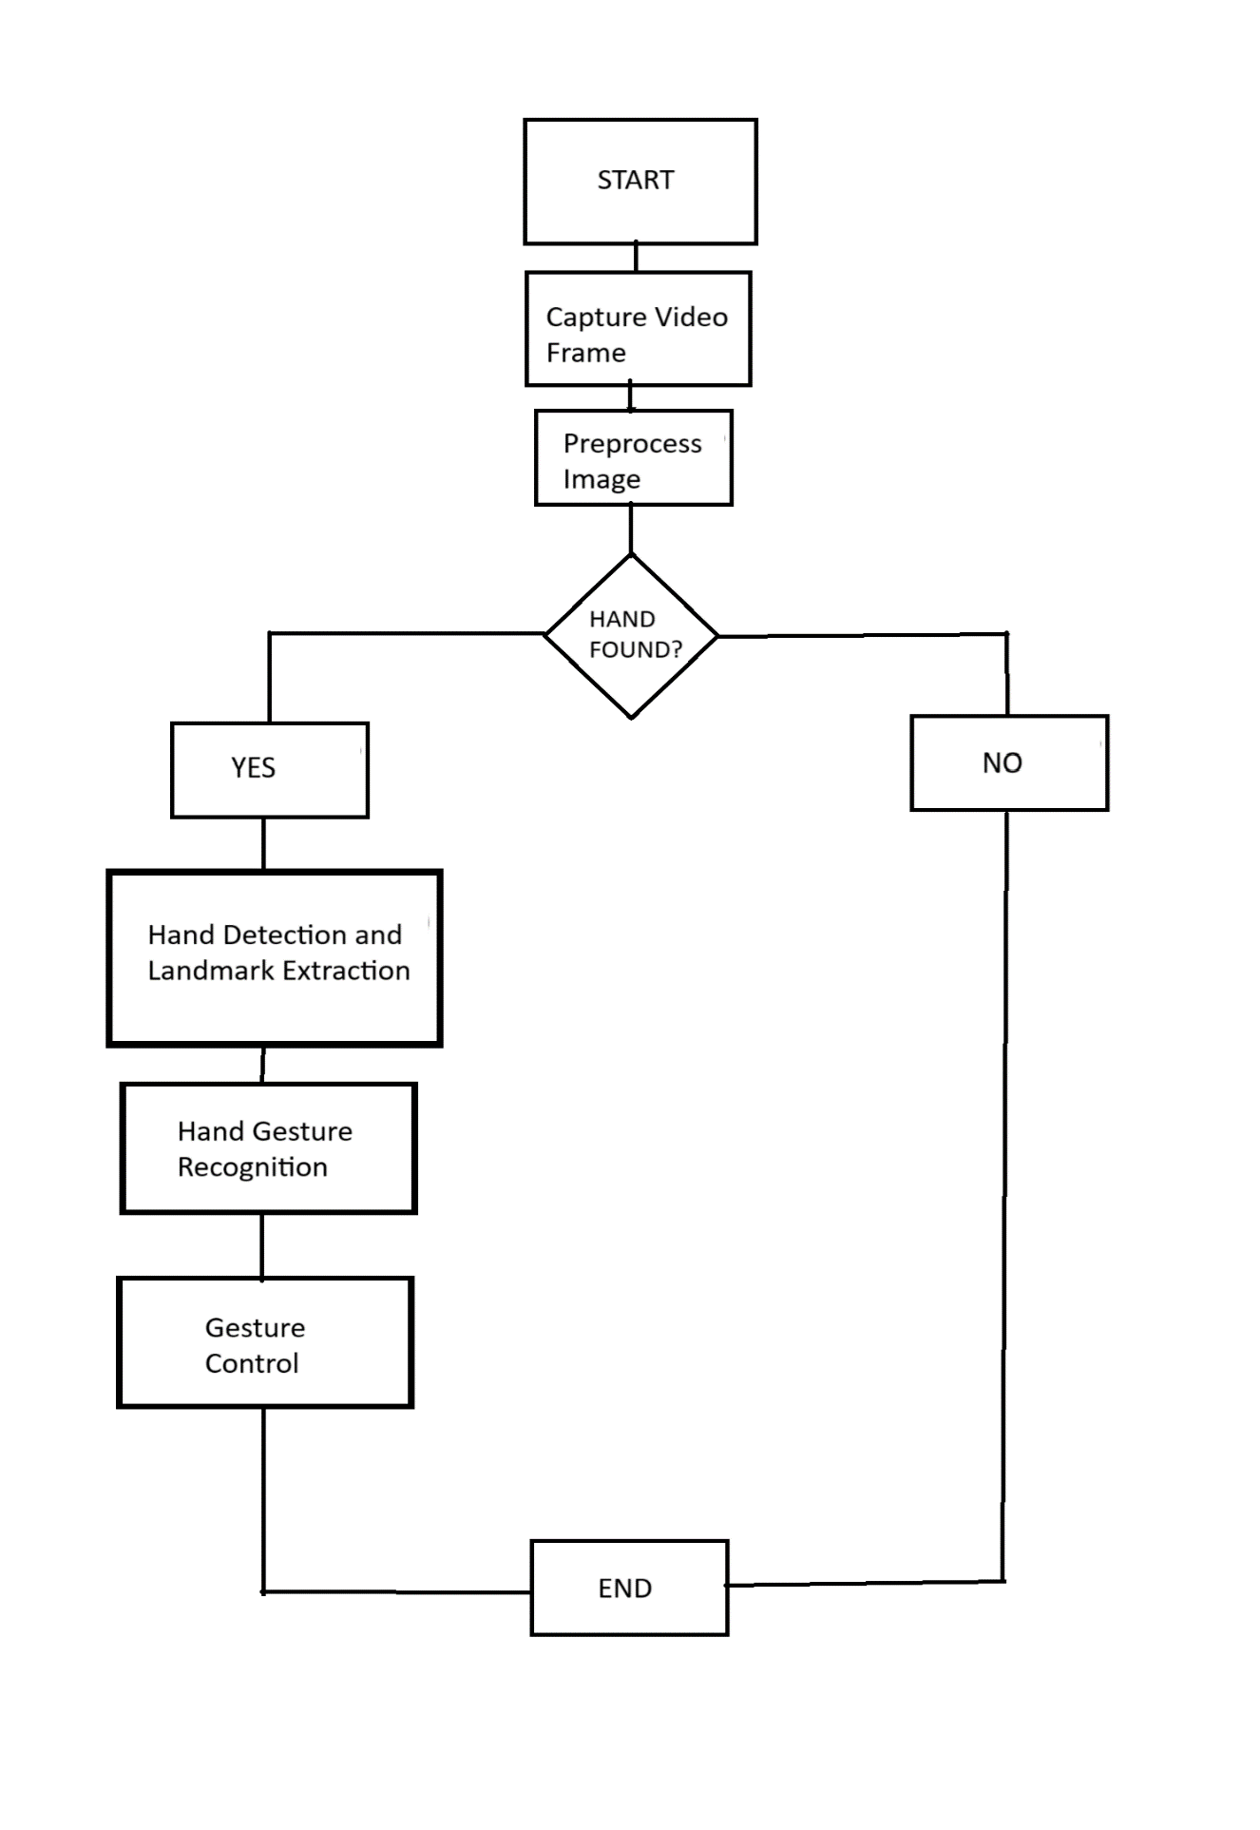Below is a simplified representation of the architecture:

Fig. 6.1 Flow chart of the Model

CHAPTER 7

RESULT AND ANALYSIS

1. **RESULT AND ANALYSIS**

The "Virtual Mouse Using Hand Gesture" project successfully demonstrates the potential of hand gesture recognition for computer interaction. The system effectively maps various hand gestures to control actions such as cursor movement, clicking, dragging, volume control, and screen brightness adjustment. Here is a detailed analysis of the results:

**1. Gesture Recognition Accuracy**

The system's ability to accurately recognize and differentiate between various hand gestures is critical for its functionality. The use of the MediaPipe library for hand tracking and gesture recognition has proven to be highly effective. Key observations include:

* **High Precision**: The system accurately identifies gestures with a high degree of precision, especially for basic gestures like pointing, clicking, and scrolling.
* **Consistency**: Repeated tests show consistent recognition of gestures, making the system reliable for continuous use.

**2. Real-Time Performance**

The system operates in real-time, with minimal lag between the gesture performance and the corresponding action on the computer. This is crucial for user experience, as any significant delay could hinder usability.

* **Frame Rate**: The application maintains a stable frame rate, ensuring smooth tracking of hand movements
* **Responsiveness**: Actions such as cursor movement, clicks, and drag-and-drop operations respond promptly to gestures.

**3. Volume and Brightness Control**

The pinch gesture is effectively used to control system volume and screen brightness. This functionality showcases the versatility of gesture-based controls beyond basic mouse actions.

* **Volume Adjustment**: Horizontal pinch movements accurately increase or decrease the system volume
* **Brightness Adjustment**: Vertical pinch movements adjust the screen brightness smoothly.

**4. User Experience**

The overall user experience is positive, with users appreciating the novelty and practicality of controlling their computer using hand gestures. Key points from user feedback include:

* **Intuitive Controls**: Users find the gesture controls intuitive and easy to learn.
* **Hands-Free Operation**: The ability to control the computer without physical contact is seen as a significant advantage, especially for tasks requiring clean or sterile environments.

**5. Limitations and Areas for Improvement**

While the project achieves its primary goals, there are areas where improvements can be made:

* **Gesture Ambiguity**: Certain gestures, particularly those involving multiple fingers, can sometimes be misinterpreted, leading to unintended actions
* **Environmental Constraints**: The system's performance can be affected by lighting conditions and background noise. Ensuring proper lighting and a clear background can help mitigate these issues.
* **Extended Functionality**: Adding more customizable gestures and expanding the range of controllable actions could enhance the system's utility.

**6. Comparative Analysis**

When compared to traditional input devices like a mouse and keyboard, the virtual mouse using hand gestures offers several advantages and some trade-offs:

* **Advantages**:
  + **Hands-Free Operation**: Ideal for situations where touching devices is impractical or undesirable.
  + **Novelty and Engagement**: Provides a unique and engaging way to interact with computers.
* **Trade-offs**:
  + **Learning Curve**: New users may need time to become proficient with gesture controls
  + **Precision Tasks**: For tasks requiring fine precision, such as graphic design or gaming, traditional input devices may still be preferable.

Overall, the "Virtual Mouse Using Hand Gesture" project demonstrates the feasibility and potential of gesture-based computer interaction. While there is room for improvement, the system offers a promising alternative to traditional input methods, particularly in scenarios where hands-free operation is desirable or accessibility is a concern.

CHAPTER 8

OUTPUT

1. **OUTPUT**
   * 1. 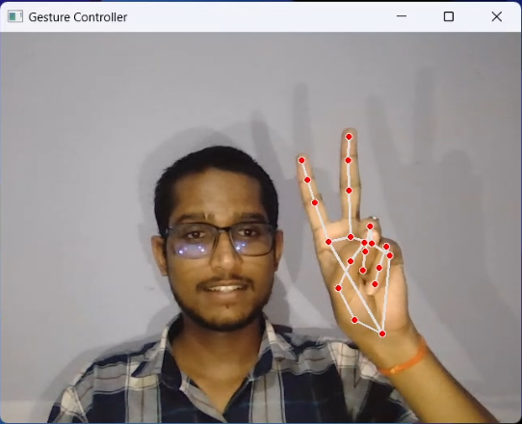Cursor Movement

Fig 9.1 Cursor Movement

"In my Virtual Mouse project, moving the cursor is achieved by extending both the index finger and middle finger away from the fist, allowing for precise and intuitive control."

* + 1. 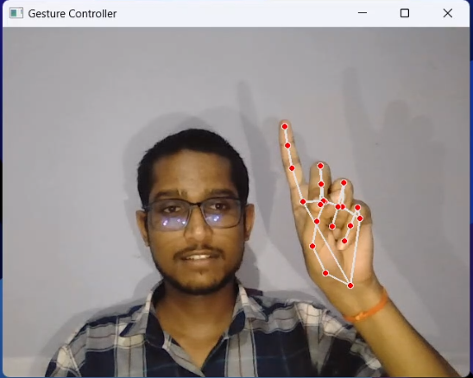Right Click

Fig 9.2 Right Click

"In my Virtual Mouse project, a right-click is performed by bringing the middle finger closer to the fist while the thumb remains away. This intuitive gesture allows for precise and efficient execution of the right-click command."

* + 1. 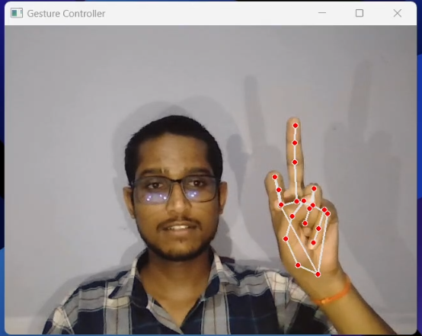Left Click

Fig 9.3 Left Click

"In my Virtual Mouse project, a left-click is performed by keeping the thumb away from the fist and bringing the index finger closer to the fist. This intuitive gesture allows for precise and efficient execution of the left-click command."

* + 1. Double Click

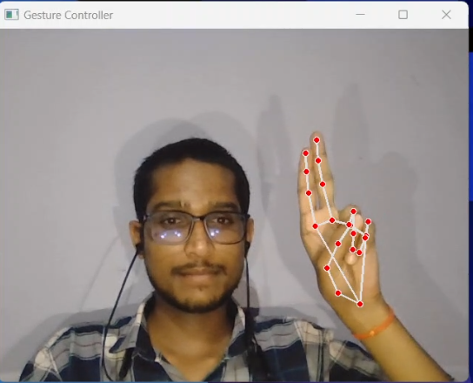

Fig 9.4 Double Click

"In my Virtual Mouse project, a double-click is performed by joining the index finger and middle finger together. This intuitive gesture allows for precise and efficient execution of the double-click command."

* + 1. Drag and Drop

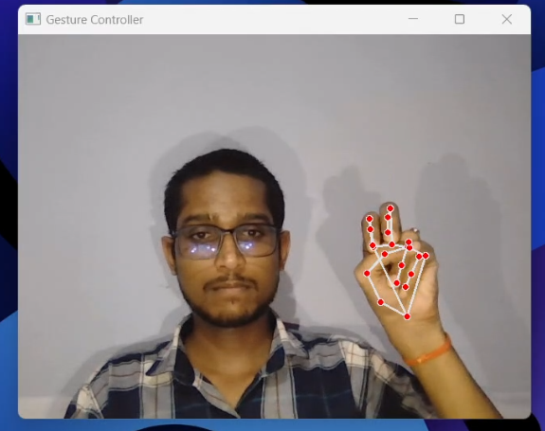

Fig 9.5 Drag and Drop

"In my Virtual Mouse project, the drag-and-drop action is initiated by bringing both the index and middle fingers closer to the fist, resembling a clenched stone. This gesture allows for smooth and accurate execution of the drag-and-drop command."

* + 1. Volume Up

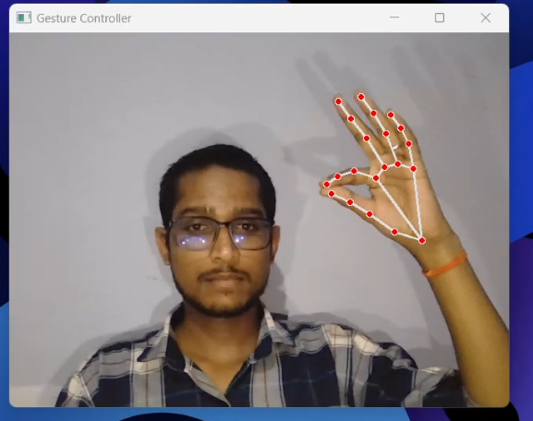

Fig 9.6 Volume Up

"In my Virtual Mouse project, to increase the volume, perform a pinch gesture by bringing the index finger and thumb together, and then raise your hand upwards. This intuitive gesture enables precise control over volume adjustments."

* + 1. 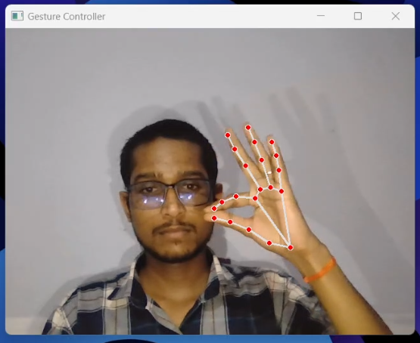Volume Down

Fig 9.7 Volume Down

"In my Virtual Mouse project, to decrease the volume, perform a pinch gesture by bringing the index finger and thumb together, and then lower your hand downwards. This intuitive gesture allows for precise volume control."

* + 1. Brightness Up

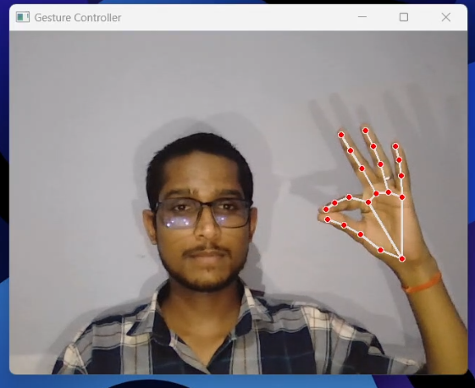

Fig 9.8 Brightness Up

"In my Virtual Mouse project, to increase brightness, perform a pinch gesture with the index finger and thumb together, and then move your hand towards the right. This gesture enables precise control over brightness adjustments."

* + 1. Brightness Down

Fig 9.9 Brightness Down

"In my Virtual Mouse project, to decrease brightness, perform a pinch gesture with the index finger and thumb together, and then move your hand towards the left. This gesture allows for precise control over lowering brightness levels."

CHAPTER 9

CONCLUSION

1. **CONCLUSION**

The "Virtual Mouse Using Hand Gesture" project epitomizes the convergence of innovation and practicality, demonstrating how cutting-edge technology can revolutionize human-computer interaction. By replacing conventional input devices with intuitive hand gestures, this project not only enhances user convenience and efficiency but also underscores the vast potential of gesture recognition technology. The system’s ability to accurately interpret a variety of hand gestures in real-time showcases the advancements in machine learning and computer vision, providing a glimpse into the future of seamless and natural user interfaces.

This project addresses practical challenges in accessibility, allowing individuals with physical impairments to interact with computers more easily, and offers hands-free operation, which is particularly beneficial in sterile environments such as healthcare settings. Moreover, the implementation of functionalities such as right click, left click, double click, drag and drop, volume control, and brightness control highlights the versatility and robustness of the developed system.

Looking ahead, the potential for further development is immense. Future iterations could incorporate adaptive learning algorithms to personalize the system to individual user behaviors, integrate with augmented reality (AR) and virtual reality (VR) environments for immersive experiences, and expand gesture libraries to cater to more complex commands. Additionally, extensive user studies could provide valuable insights to continually refine the system’s usability and effectiveness.

In conclusion, the "Virtual Mouse Using Hand Gesture" project is a testament to the transformative impact of modern technology on everyday tasks. It not only paves the way for more natural and accessible computing experiences but also sets a benchmark for future innovations in human-computer interaction. This project’s successful implementation and its potential for future enhancements make it a significant contribution to the field of gesture-based interfaces, showcasing the limitless possibilities that lie ahead.